Thai Co Nguyen

Lofaro

March 20th, 2019

**ECE370 Motor Driver and Servoing**

**Video Link of Motor Running:** https://youtu.be/IJvgQwpPYak

**Description:**

For this project, we use the H-bridge and wheel encoder that we created in our previous homework assignments to create a set-up that can control the angle at which a motor can spin. The motor should be able to spin forward and backward up to 720 degrees!

**Schematic of test set-up:**

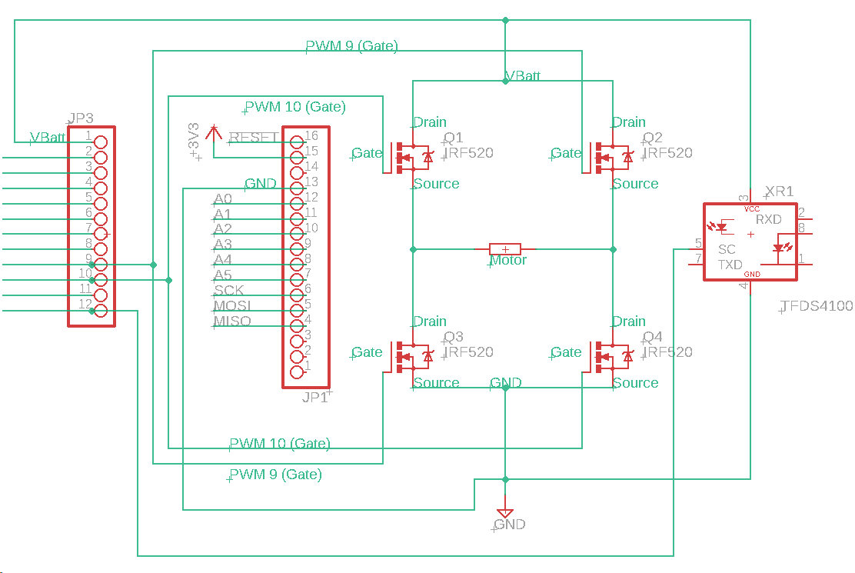

**Pseudo Code:**

pinMode(forward);

pinMode(backward);

if(Serial.available())

getAngle()

convertAngletoNumberOfTicks()

loop()

{

If(ticks == desiredNumberofTicks)

analogWrite(forward, 127) //stop

analogWrite(backward, 127)

reset numberOfTicks/currentTicks;

if(angle is negative)

analogWrite(forward, 127) //go backward

analogWrite(backward, 255)

If(angle is positive)

analogWrite(backward, 127) //go forward

analogWrite(forward, 255)

}

**Results:**

|  |  |
| --- | --- |
| **Angle Desired** | **Experimental Angle** |
| 0° | 0° |
| 45° | 20° |
| 90° | 85° |
| 180° | 195° |
| 360° | 400° |
| 720° | 810° |
| -45° | -22° |
| -90° | -85° |
| -180° | -190° |
| -360° | -390° |
| -720° | -830° |

These results make sense, because when the angle is very small, the time it takes the encoder wheel to start spinning must be taken into account as the sensor will sense “more” ticks at slower wheel speed. Due to this, small angles will result in a slightly smaller experimental angle result. In contrast, larger angles greater than 250° or so takes longer to stop spinner due to inertia, so larger angles will results in larger experimental angle results. The same happens when going backward and forward. I find that this motor is most accurate between 150°-250°.

**Picture of Test Set Up:**

